**John Hutchison**

**EDPS 602**

**Final Project**

**Purpose:**

The main purpose of this report is to determine if there is a gender gap in pay among faculty/staff at Ball State University (BSU). The scope of this report will focus on full-time instructional nonmedical staff and will include all academic ranks. The salary data from BSU will then be compared to Indiana State University (ISU), a peer institution of BSU.

**Methodology:**

The data used in this study was taken from the National Center for Education Statistics. The first analysis includes average salary data for men and women at each academic rank for the 2022-2023 academic year, equated to 9-months worked. This data from BSU was compared to the same data from ISU to determine how BSU compares to a peer institution. After the analysis for the 2022-2023 academic year, salary data was analyzed for the last four years to understand how the gender gap in pay has changed over recent years. Lastly, potential moderating variables were examined to understand potential reasons that explain the pay gap. To give an idea of the sample size for this study, Table 1 displays the number of staff included during the 2022-2023 academic year.

Table 1: Number of staff included during the 2022-2023 academic year salary analysis

**Analysis:**

BSU:

Figure 1 illustrates the average salary for men and women at each academic rank for the 2022-2023 academic year at BSU. We see that for most academic ranks, the average salaries for men and women are comparable. However, as academic rank increases, the pay gap becomes more significant. The largest pay gap is seen at the highest academic rank of professor and totals to $8,286.

Figure 1: Average Salaries of full-time instructional nonmedical staff equated to 9-months worked, by academic rank and gender, 2022-23, BSU.

Indiana State University:

Figure 2 illustrates the average salary for men and women at each academic rank for the 2022-2023 academic year at ISU. Just from observation, it is evident that the gender gap in pay at ISU is much smaller than BSU. The largest pay gap at ISU is seen at the academic rank of associate professor, and totals to $3,425.

Figure 2: Average Salaries of full-time instructional nonmedical staff equated to 9-months worked, by academic rank and gender, 2022-23, ISU.

Trend Data:

To understand how the gender gap in pay has changed over recent years, a pivot chart was utilized to quickly compare the average salaries by academic year at BSU. Figure 3 shows a screenshot of the pivot chart to give a visual idea of how the chart operates.

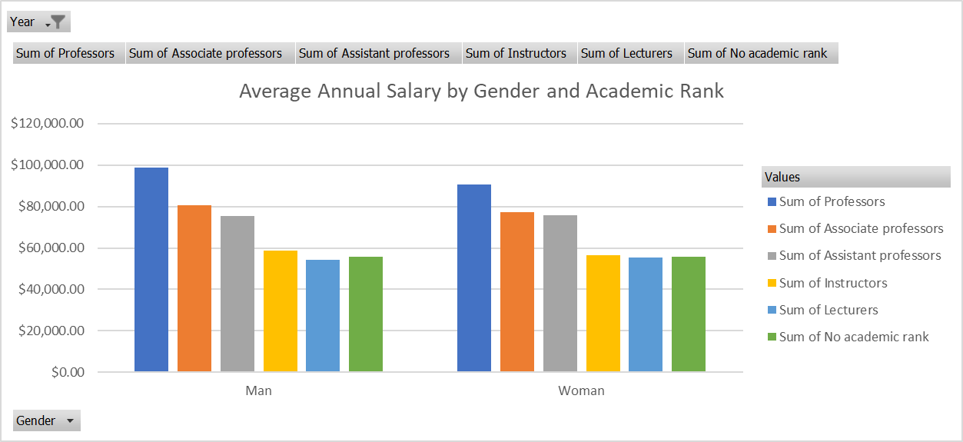

Figure 3: Screenshot of pivot chart used to analyze salary data by year

Figure 4 illustrates the average gender salary gap for professors over the last 5 years. This graph only includes data for professors because that is the only academic rank in which the salary gap was deemed significant. By observing the graph, we see that significant improvements have been made when considering the gap size in 2018 versus 2023. However, the gap increased slightly from 2022 to 2023, which is concerning. It will be important to stay cognizant of the gap in the future years.

Figure 4: Average salary gap by academic year for professors at BSU from 2018-2023

**Mitigating Variable – Tenureship/Years of Service**

I predict that the most influential mitigating variable on the pay gap is whether a professor is tenured. Being a tenured professor implies a higher number of years working at the institution, and usually tenured professors have higher salaries. Table 2 shows data for full-time instructional staff with faculty status that are tenured. We see that there are much more men that are tenured than women (217 and 168, respectively). This difference is highest for the academic rank of professor, which also exhibits the largest gender gap in pay. Thus, it is reasonable to assume that male professors have a higher proportion of tenureship, which would result in a higher average salary for them.

Table 2: Tenureship data for men and women instructors at BSU, 2022-2023.

**Conclusion:**

This report offers insights into the gender gap in salary among faculty/staff at BSU. The data suggests that there is a significant pay gap at the highest academic rank of professor. When compared to a peer institution (ISU), BSU had a much larger pay gap. While the trend data shows this gap to be decreasing over the last 5 years, the gap slightly increased from 2022-2023, so BSU must act now to bring this gap down. BSU should focus on increasing tenureship for women professors. This would help decrease the gap for professors which is the only academic rank with a significant gap. This study was limited to only two genders: men and women. Data was not easily accessible for non-binary individuals, which is another shortcoming of BSU. I hope that BSU will attempt to remedy this in coming years. If this study were continued, the next steps should focus on how race and ethnicity affect salary along with gender. The results of this study will hopefully aid in holding BSU accountable in the effort to create a truly equitable environment.